**Tooth Registration Pipeline**

**Luke Hammond // Cellular Imaging Platform**

**I. Installing**

* These tools have been developed for PCs (should work on mac but haven’t tested)

1. Install **Fiji/ImageJ**. Fiji can be downloaded at: http://fiji.sc/Fiji
2. Install the Tooth Registration Pipeline
   * Download CI_Tooth_Reg.jar at
   * Copy the **CI_Tooth_Reg.jar** file into your ImageJ plugins folder

**II. Step-by-step use of the Tooth Registration Pipeline**

1. Separate the tooth files into 4 subfolders based channel information. These folders should be named as below:
   * AF
   * CRP
   * DMP
   * Annotated

* The pipeline will sort the tooth files in these folders alphanumerically, so they should be named with this in mind. E.g. each image for tooth 1138E should a have filename that begins with this.

*The pipeline only expects one image for each tooth, so fragmented teeth will need to be manually reconstructed before beginning this process.

1. In Fiji/ImageJ under Plugins (towards the bottom), run the first step of pipeline:
   * **Plugins > Cellular Imaging > Tooth Registration > 1 Reformat Tooth Images**
   * Select the main folder which contains the four subfolders.

This step automatically processes the raw data from different microscopes and in different formats (Z-stack and single images) into a common format so we can open and register the data efficiently. The processed data will go into a new folder called **Processed**

Preview images for each tooth are also crated and saved to a folder called **Preview**

Allow approximately 2-3 minutes per tooth for processing time.

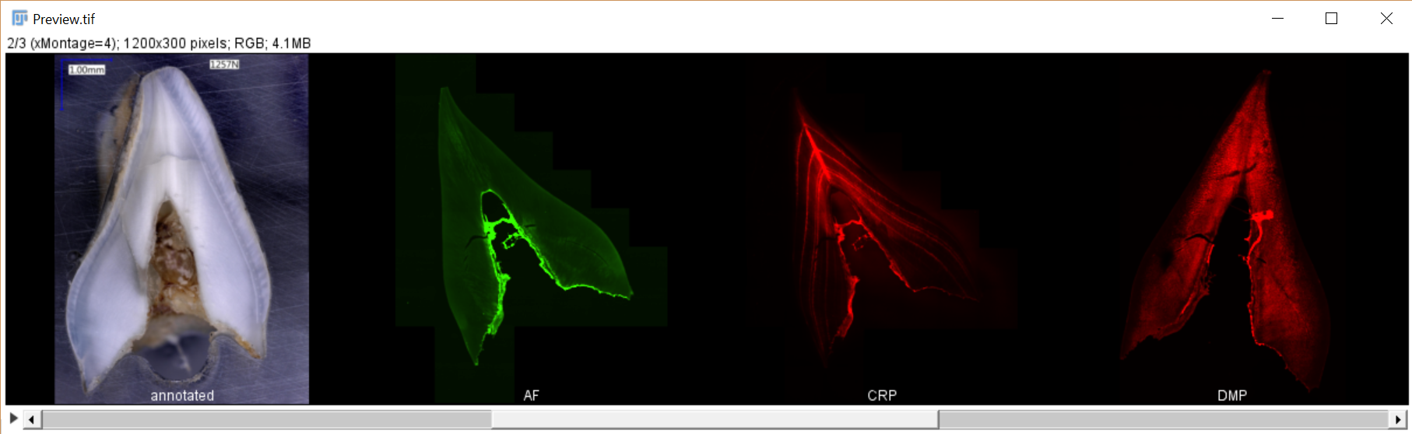

Figure 1. Example preview image

1. Open the Preview images and check for which Annotated and DMP images require flipping to ensure all images are in the same orientation.
   * If you drag the “Preview” folder on to FIJI you will be able to open the preview as an image series
2. In Fiji/ImageJ under Plugins (towards the bottom), run the second step of pipeline:
   * **Plugins > Cellular Imaging > Tooth Registration > 2 Flip Tooth Images**
   * In the window that appears, list the Annotated and DMP images that require flipping
   * For example, if the Annotated images in teeth 3 and 5 require flipping and the DMP images in teeth 4, 6 and 7 require flipping you would complete as below:

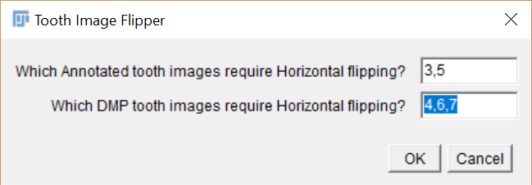

* + Then, as before, select the main folder containing all the subfolders

1. In Fiji/ImageJ under Plugins (towards the bottom), run the third step of pipeline:
   * **Plugins > Cellular Imaging > Tooth Registration > 3 Register Tooth Images**
   * As above, select the main folder containing all the subfolders.
   * If you have previously stopped the pipeline at a certain tooth, you can begin the pipeline at this tooth by typing in the tooth number (the pipeline will display the current tooth number as it is running). To start from the beginning, ensure this value is set to 0.
2. For each tooth you will first need to align the **Annotated image to the CRP image**. These images will be displayed and you will be asked to mark corresponding points
3. If necessary, adjust the CRP image brightness by clicking on the CRP image, then adjusting the brightness (Ctrl-Shift-C)
4. If you notice the Annotated image is flipped relative to the CRP image, select the Annotated image and flip **Image > Transform > Flip Horizontal**
5. Left click to add points on the CRP image, these points will be numbered. If you wish to remove a point hold Ctrl and left click on the point you wish to remove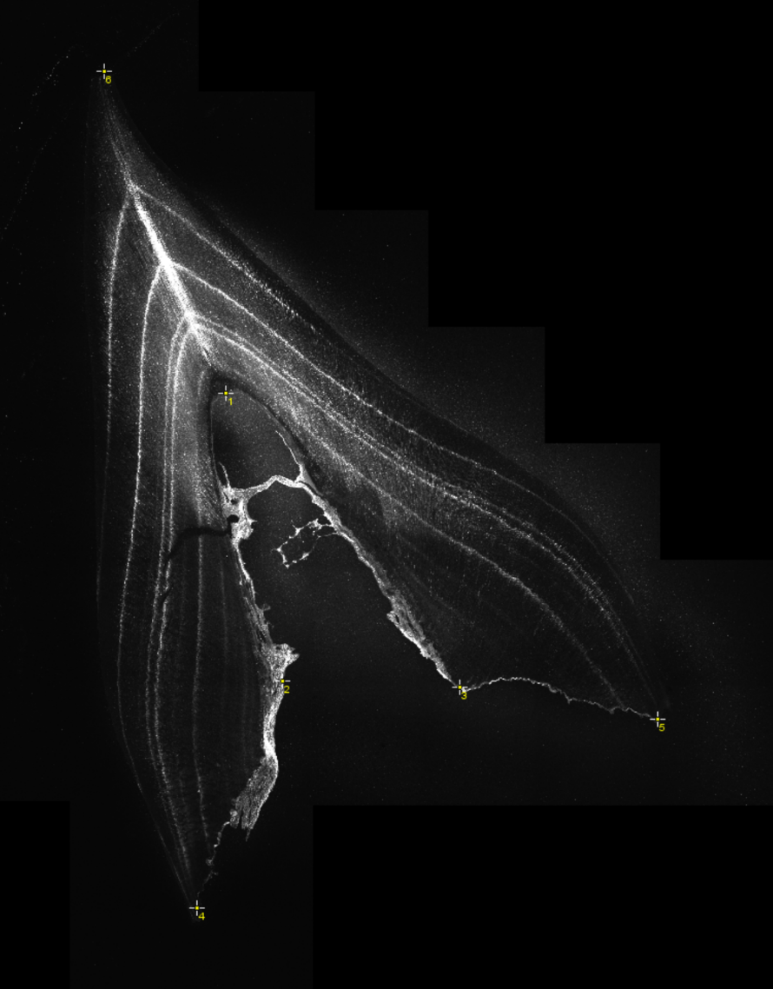
6. Add the same points to the Annotated image. **It is important the points are added in the same order** (check by looking at the number next to the point). If you need to adjust a point you can click and drag to move its location
7. When you have added sufficient points (5 recommended, please see image for advised locations), click OK
8. A translated annotated image and a merged image is displayed. If these appear OK, leave them open and click OK
9. If the registration looks unsuccessful, close the merged and translated images, adjust and/or add more points, then click OK (registration can be continually retested in this manner).
10. Complete as above for the registration of the DMP image with the CRP image
11. Once all the teeth have been registered the pipeline will create two output folders:
    * **Registered_Preview** – this folder contains low resolution images with all channels merged together, for quick inspection of results
    * **Registered_Full_Res_Merged** – this folder contains full resolution images with all four channels merged together. The annotated image is included as a monochrome channel image, but an additional full resolution registered color annotation image is also provided. This data should be used for subsequent analysis
12. When you have confirmed the registered results are correct, delete the **Preview** and **Processed** folders